GUI Thai-SEU

SimpleSpecification V0.3

Uwe Gühl
Department of Computer Engineering
Faculty of Engineering
Kasetsart University, Bangkok, Thailand


Fall 2007/ 2008

List of Contents

1 Introduction 2
2 Overall Description 3
3 System Features 5
4 External Interface Requirements 6
5 Nonfunctional Requirements 7
6 Other Requirements 8

Introduction

Purpose
Expected Result is a graphical user interface (GUI), which offers the possibility to enter search terms and to get a structured result with clusters and a result set.
The user should get offered best satisfying results, which are
- ranked in a challenging way
- as fresh as possible (there should be an intelligent synchronization)
A speciality is, that search terms could be entered in Thai, and that only Thai web pages get searched and given back.
The duration of the project is from November 2007 to March 2008.

Document Conventions
Have to be defined by the project.

Intended Audience and Reading Suggestions
This documentation is basic for the project and should be read by each participant student.

Project Scope
It should be possible to allow the user to enter different search terms and to get an appropriate set of results.
Additionally the results should be clustered.

References
One possible idea of realization is shown by Carrot Clustering Engine at http://project.carrot2.org/
This document follows the Software Requirements Specification template by Karl E. Wiegers.

Overall Description

Product Perspective
GUI Thai-SEU is part of a new product “Thai-SEU”, combining the work of different MasterThesis- and PhD-Students in MIKE-lab at Department of Computer Engineering at Kasetsart University.

Product Features
Important features are
- a comfortable easy-to-use search entry field
- he possibility to enter Thai search terms, and
- a well-structured feed back,
- additionally with clustering-information to have easy access to the requested information.
- Differentiation of regular search and expert search.

User Classes and Characteristics
- User: Regularly User
- Developer: .Developer, who gets more information for optimizing research (like system configuration etc.)

Operating Environment
The software should work on PCs and Laptops using Microsoft Operation Systems like XP or Vista, and Linux, and on Workstations using UNIX-Derivatives.

For testing purposes we use mainly the XP or Vista (or better) operating system, but it should be tested on Linux and UNIX-systems as well.

Design and Implementation Constraints
The software should be easy accessible in the Internet as a webpage, it should follow GUI-guidelines to guarantee an user friendly access.
For testing purpose a stand-alone-application is possible without internet connection.

User Documentation
A user manual and help should be available. Help and Guidelines should be available via a Link from the website.

Assumptions and Dependencies
There should be no dependency to other programs.

System Features
This chapter describes the Business Processes and the Use Cases of the systems.

Basic search

Thai basic search

Expert search

Request to restructure cluster

Choosing a proposed cluster

Help

(Information) request / Bug report

External Interface Requirements

User Interfaces
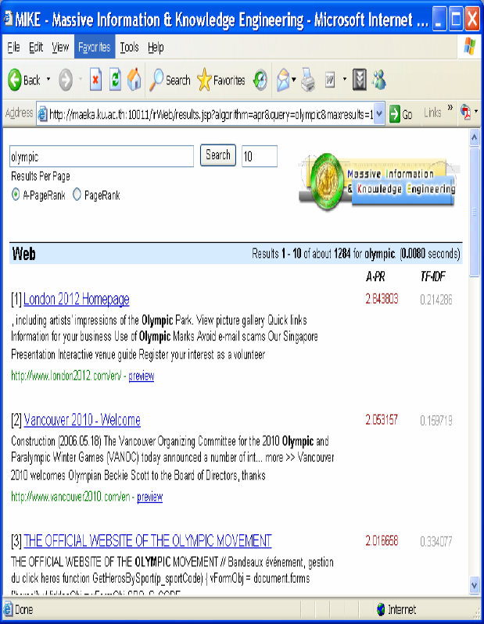
Suggestion:

Hardware Interfaces
Not defined.

Software Interfaces
Connection to package “Search-Service” of Thai-SEU.

Communications Interfaces
Http-Connection to Thai-SEU.

Nonfunctional Requirements

Performance Requirements
Maximum 4 seconds processing time of an user request.
No significant performance difference because of number of users who use the application parallel (Limit 5,000 User).

Client environment is not considered.

Safety Requirements
No side effects, should not damage anything on a computer.

Security Requirements
Respect of the privacy of an user.

Software Quality Attributes
Adaptability it should be usable for other software projects
Availability Website should be accessible at least 23 hours a day
Correctness The shown results should fit in the best way to the search request.
Flexibility New requirements should be easily realized
Interoperability Communications with Thai-SEU specific services must work.
Maintainability Configuration should be done easily and repeatable, even after shut-down of the application
Portability It should be possible to run the system standalone (optional)
Reliability It should not be possible to crack the website.
Reusability The code should be programmed in the way, components could be reused by other applications
Robustness The application should not generate a core dump.
Testability The application must be testable.
Usability Easy to use instead of easy to learn.

Other Requirements
The software should be written as open source.

Programming language to use is Java.
Development Environment is Eclipse.

Appendix A: Glossary
GUI = Graphical User Interface

Appendix B: Analysis Models
to be defined
Appendix C: Issues List
to be defined

